CALENDAR CHART BASCIS: ASSIGNMENT 6

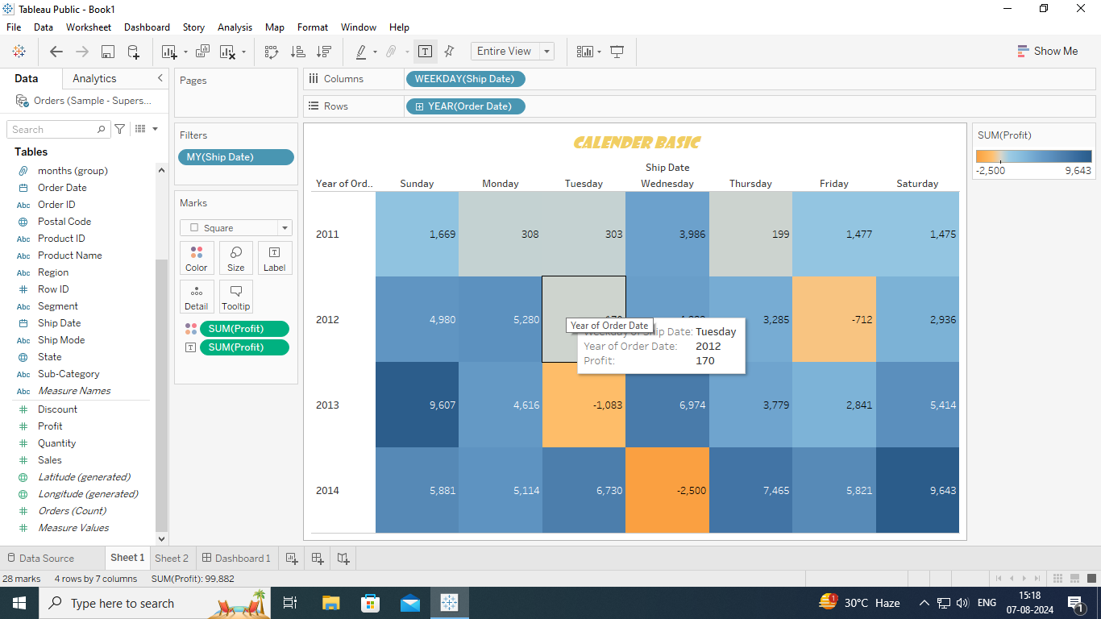

CALENDAR ADVANCED CHART:

